IOT BASED AIR POLLUTION MONITORTING SYSTEM

BY

BOREDDY CHAITANYA KUMAR REDDY 19BEE1001

ABISHEK S 19BEE1094

R JITENDRA PRASAD 19BEE1153

N BHUVAN 19BEE1156

**Highlights**

* Air quality indexes can be monitored in the web UI and mobile application using IBM Watson IoT platform.
* A SMS will be sent to the user when the air quality goes beyond a certain level.
* Forecasting using predictive analysis.

**Abstract**

Developing an IOT Based pollution Monitoring System which will monitor the Air Quality over an internet server using IBM Watson and forecast using predictive analysis. Existing monitoring systems have inferior precision, low sensitivity, and need laboratory analysis. Therefore, improved monitoring systems are needed. To overcome the issues of existing systems. It will show the air quality in PPM on the mobile application and also as on the web page in order that will able monitor it very easily.

**Introduction**

Developed a low cost sensor nodes that is electrochemical sensor to measure carbon monoxide and nitrogen dioxide and an infrared sensor for particulate matters levels. those nodes are capable of long range, low power communication over public or private LoRaWAN and short range using wi-fi[1].when the vehicle's windows are open, that air will travel inside and outside through the opening window, it extracts the concentration of pollutant in the condition that the concentration trend is convergent after opening the windows, the obtained value is denoted as the equivalent air quality of the surroundings[2]. To identify the IOT based real time monitoring strategies to study the  effect of particulate matters in human health, the main use of this is to increase the coverage and density of environmental monitoring stations impact of PM on human health[3].PM forecasting – auto regressive integrated moving average and vector autoregressive models is proposed and evaluated with a  30days PM data set collected from 15LoRa based PM sensor nodes installed at a university campus[4]. It is based on a compact and low-power integrated system includes both sensing and processing. sensing is performed through a microchip processing is based on Machine learning techniques[5].Developed an indoor air quality monitoring system for people who spend more than 90% of their time in indoor, An air quality detector measure co2, ,temperature, humidity has been designed and tested in residential buildings[6]. Main motive of the system is to monitor the greenhouse environment  and control the internal temperature to improve productivity[7].In this paper, they proposed a new method to implement based on state-of-the-art Internet-of-Things techniques. In this system, portable sensors collect the air quality information timely, which is transmitted through a low power wide area network. low power wide area technology, an emerging Machine-to-Machine communications technique may be used[8]. A novel indoor air quality detector integrated with multiple communication interfaces has been designed, built, programmed deployed and tested. The IAQD measures the indoor air quality data, including temperature, humidity, CO2, dust and formaldehyde timely[9].The proposed monitoring system embodies a device made of various gas sensors, a GSM module, a cloud server, and a mobile application. In our implemented device, one can easily access the data from the server and app to monitor the air pollution condition[10].These ML algorithms are support vector machines, M5P model trees, and artificial neural networks (ANN). Two types of modelling are pursued: 1) univariate and 2) multivariate. The performance evaluation measures used are prediction trend accuracy and root mean square error (RMSE). The results show that using different features in multivariate modelling with M5P algorithm yields the best forecasting performances[11]. This paper reports the development of a novel low cost sensor node that utilizes cost-effective electrochemical sensors to measure Carbon Monoxide (CO) and Nitrogen Dioxide (NO2) concentrations and an infrared sensor to measure Particulate Matter (PM) levels. The node can be powered by either solar-recharged battery or mains supply[12].The smart transducer interface module was implemented using the analog devices. Network Capable Application Processor (NCAP) was developed using a personal computer and connected to the STIM via the transducer independent interface[13]. The system consists of multiple compact sensor units that can measure residential NO2, ozone, humidity, and temperature at one-minute resolution and a cloud-based informatic system that acquires, stores, and visualizes the microenvironmental data in real-time[14].

Therefore, OMI will contribute significantly to study of the ozone layer, air quality, and climate change. Near Real Time products of OMI can be used for UV-B, weather and air quality forecasts, and aircraft avoidance control[15]. The proposed framework is highly scalable and sustainable with the potential to facilitate the Internet of Things, smart cities and citizen science in the future we developed a number of advanced data services for data visualization, abnormal device detection, and tracing the sources of pollution emissions[16].

The system successfully reports CO2 concentration of four rooms to the system administrator on time through a Graphical User Interface (GUI)that is also developed[17]. the state-of-the-art low-cost air pollution sensors, identify their major error sources, and comprehensively survey calibration models as well as network re-calibration strategies suited for different sensor deployments[18]. used the GSM wireless communication module. The developed system is capable of real-time measurement of air polluted gases such as CO2, CO, NO2, and SO2[19].with a network of low cost and autonomic wireless sensors, aiming at a finer spatiotemporal granularity of sensing. Generic deployment models of the literature are not adapted to the stochastic nature of pollution sensing[20]. there will be adequate concentrations of harmful gases, including CO2, smoke, alcohol, benzene, NH3, and NO2. The system uses air sensors to sense and transfer this data for the microcontroller[21]. In this proposed a system that will provide good air quality data and comprises of gas sensors GSM module cloud server and mobile application. The device has unique features such as mobility and extensibility and user friendly[22]. The system utilizes air sensors to detect and transmit this data to microcontroller. Then the microcontroller stores the data into the web server.For predicting LSM[23]. technology to monitor the acquired data and process the data. The obtained data is predicted using a neural network[24,25].The techniques included decision Multi-Layer Perceptron Regression [26].this paper is to quantify the effect of event-based sensing strategies event-based sensing strategies, we now present the IoT node electronic configuration that enabled us to evaluate power consumption and battery lifetime[27].PM concentration & Air Quality Index changes with respect to environmental factors like air moisture, dew point, humidity, temperatures well as barometric pressure, therefore we cannot ignore involvement of all these factors[28].

In order for a device to be part of the Internet of Things, it must be able to communicate with other devices. Therefore, it requires some sort of built-in wired or wireless communication. Most IoT devices are Wi-Fi enabled, but Bluetooth also can be wont to transfer data to nearby devices. IoT devices are commonly called “smart devices”, since they're ready to communicate with other things. Along with the capacity to speak, many IoT devices also include an array of sensors that provide useful information. IoT Based Air Pollution Monitoring System which will monitor the Air Quality using Node-red & IBM Watson and will send a SMS to user when the air quality goes down beyond a certain level, means when there are sufficient amount of harmful gases are present in the air like ozone(O3), carbon-monoxide(CO), sulphur dioxide(SO2), nitrogen dioxide(NO2), and particulate matter(PM). It will show the air quality on the mobile application and as well as on web UI so that monitor the pollution level from anywhere using mobile. An IoT based air pollution detection is developed. It deals with the collection of data from gas sensors using Arduino. The data collected is stored, processed and can be monitored using the Mobile Application. Users can review the stored data through the application.

**Methodology**

**Arduino Uno**

The Arduino Uno microcontroller board is based on the ATmega328P microcontroller (datasheet). It features 14 digital input/output pins (six of which can be used as PWM outputs), six analogue inputs, a 16 MHz quartz crystal, a USB port, a power jack, an ICSP header, and a reset button. It comes with everything you need to get started with the microcontroller; all you have to do is plug it into a computer via USB or power it with an AC-to-DC adapter or battery**.**

This project is starts with Mq135 sensor which is used to detect the air quality gas sensor, which can detect gases like ammonia (NH3), sulphur, benzene, CO2 and other harmful gases and smoke.

MQ135 Sensor Specifications

The MQ135 is a prominent gas sensor from the MQ series, which is frequently used in air quality control systems. It can offer both digital and analogue output and runs between 2.5 and 5.0 volts. Below are the pinouts and essential components on a MQ135 Module. Pinout for the MQ135 Sensor Module

It's worth noting that all MQ sensors must be powered up for a pre-heat period before they can begin working. This pre-heat time usually ranges from 30 seconds to a few minutes. The power LED will light on when you turn on the module; leave it in this mode until the pre-heat period is finished.

Python

IDLE is a text editor that works in a similar way to Python Shell. IDLE is a Python editor that allows you to write, modify, and run Python code. IDLE is a full-featured text editor that includes syntax highlighting, auto-completion, and smart indent for writing Python programmes.

NODE-RED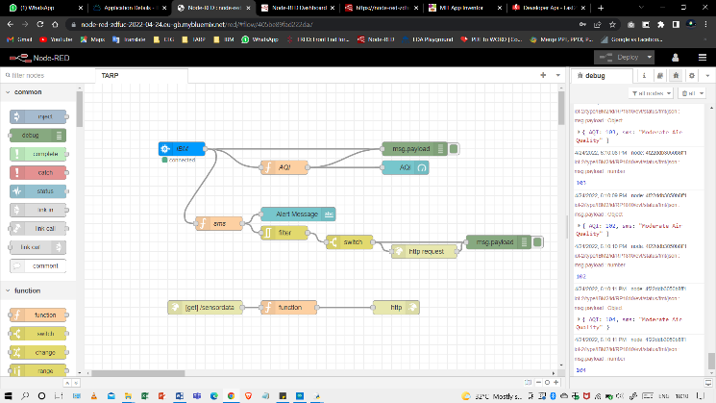

Node-RED is a visual programming tool. It visualises relationships and functions and allows users to programme without having to type in a language. Node-RED is a browser-based flow editor that allows you to create, remove, and connect nodes to have them communicate with one another.

IBM CLOUD

With proven architecture patterns and processes for rapid delivery for operating mission-critical workloads, IBM Cloud offers solutions that enable better levels of compliance, security, and administration.

MIT APP INVENTOR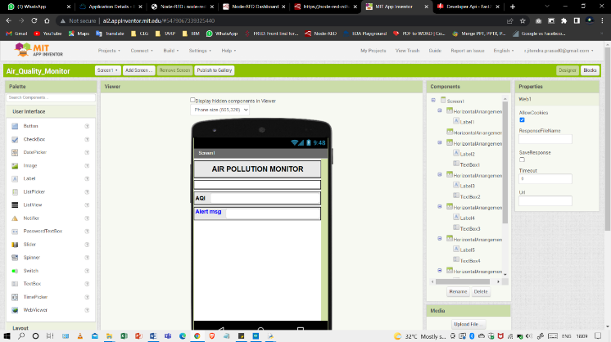

MIT App Inventor is a tool for teaching computational thinking in a number of educational environments, and it teaches individuals how to build apps to solve problems in their communities.

FAST2SMS

Fast2SMS provides a bulk SMS API that ensures security and is a very reliable source of data transmission. Add contacts using QR codes — Fast2SMS allows you to add contacts using QR codes. The acronym QR stands for "rapid response." The biggest advantage of QR codes is that they take up very little space when it comes to storing information. 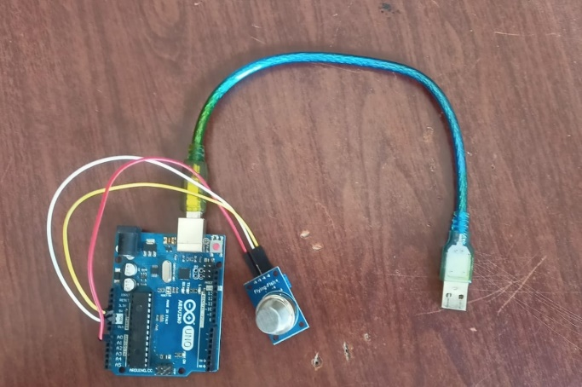

With these specifications connecting this to the Arduino which has been code using this particular code can produced the gas levels Using this command this is connected to the python which can be used to produce PPM of the air nearby the Mq135 sensor. Connecting the python result with IBM using device credential, which can be used to create a new device in IBM and store the results, produced using python. Using Node –Red which has IBM IOT node connecting the required gases .these are further displayed in the gauges and msg.payload. Using the function node named SMS which is used to send messages when it encountered any change in the values ,which is further connected to MIT app inventor which is used to send messages to the phone by creating an mod apk file .The switch in the flow give an alert when the values cross the threshold values. Getting Started with MIT App Inventor. App Inventor is a cloud-based tool, which can be used to build apps right in the web browser. This website offers all the support need to learn how to build an apk file. Can be visited it at ai2.app inventor.mit.edu. After setting some connections are needed to develop for the app view with in same "http/in" & "http/response" node with including some .functions and to develop an app is using the help of MIT APP INVERTER Fast2SMS system which is used to send SMS to the user which send the message only when the limits cross the threshold values. Fast2SMS system designed to deliver millions of SMS at a time. The results which are displayed in the message and the apk file are then transferred in to IBM cloud.

**RESULTS**

As a result, this project is to check the quality of the exposed level in the air pollution. The low cost, efficient, real-time air quality monitoring system using IBM Watson has been

implemented and tested. Through this system, the officials can keep track of the levels of

pollution occurring in the air and send immediate warnings to the public. The system can be easily installed, with the base station kept close to the target area, and the task of monitoring can be done by less-trained individuals. 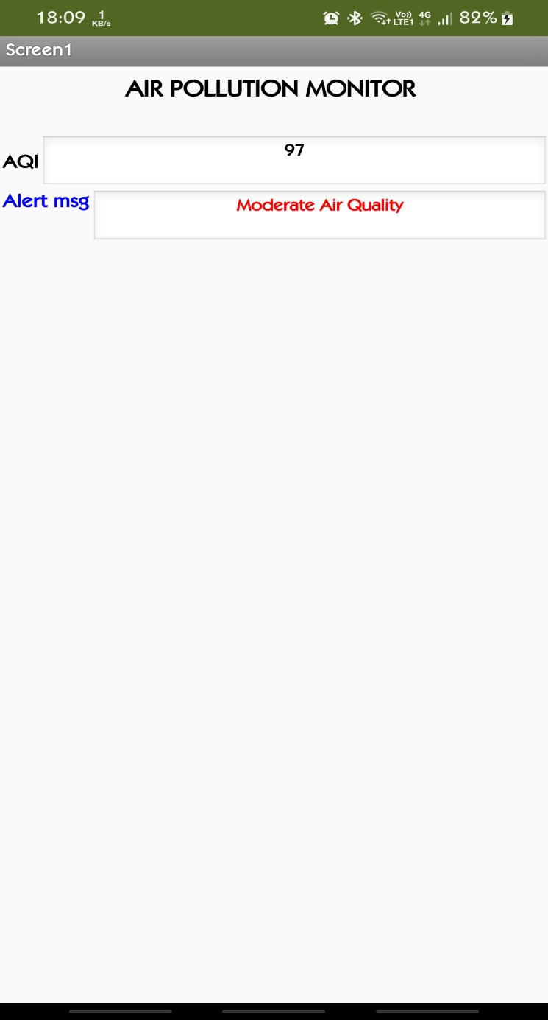Internet of Things (IoT) and its services are becoming part of our everyday life, ways of working, and business. There is a great deal of research on developing crucial building blocks and models for the next generation Internet services supported by a plethora of connected things.

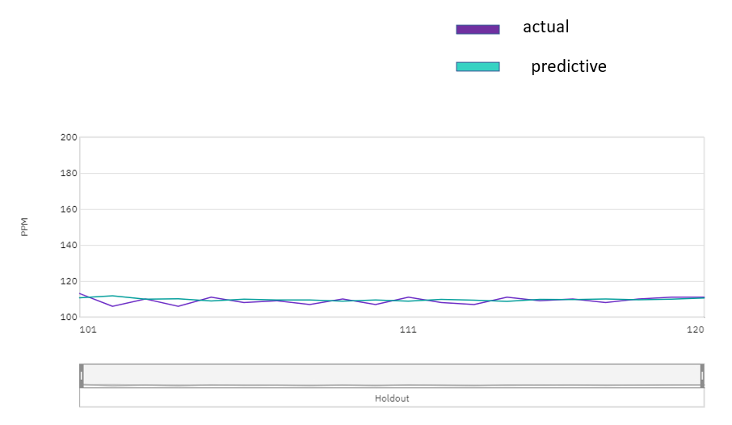

By utilising IBM Watson, auto AI will be able to forecast future quality in a given location based on historical data. This graph shows that both the actual and predicted values are approaching each other. This will inform users how effective it is at its job.

**CONCLUSION**

The sensors employed in this proposal will collect data, which will then be analysed for usage in the next step. This paper proposes a clever and economical technique to monitor the environment. Experiments with an air pollution monitoring system based on the Internet of Things idea were conducted. The sensed parameters were sent with the help of one sensor.in the Cloud Furthermore, this data will be beneficial in the future and able to predictive by using ML .Individuals can successfully discuss the results of their inquiry. Finally, this proposed approach will aid in monitoring air pollution levels and, as a result, ensure general wellbeing in an effective and simple manner, as well as provide a consistent response to screen nature.

**References**

1. S. Ali, T. Glass, B. Parr, J. Potgieter and F. Alam, "Low Cost Sensor With IoT LoRaWAN Connectivity and Machine Learning-Based Calibration for Air Pollution Monitoring," in IEEE Transactions on Instrumentation and Measurement, vol. 70, pp. 1-11, 2021, Art no. 5500511, doi: 10.1109/TIM.2020.3034109.
2. J. Huang et al., "A Crowdsource-Based Sensing System for Monitoring Fine-Grained Air Quality in Urban Environments," in IEEE Internet of Things Journal, vol. 6, no. 2, pp. 3240-3247, April 2019, doi: 10.1109/JIOT.2018.2881240.
3. M. J. Diván, M. L. Sánchez-Reynoso, J. E. Panebianco and M. J. Méndez, "IoT-Based Approaches for Monitoring the Particulate Matter and Its Impact on Health," in IEEE Internet of Things Journal, vol. 8, no. 15, pp. 11983-12003, 1 Aug.1, 2021, doi: 10.1109/JIOT.2021.3068898.
4. J. Yun and J. Woo, "IoT-Enabled Particulate Matter Monitoring and Forecasting Method Based on Cluster Analysis," in IEEE Internet of Things Journal, vol. 8, no. 9, pp. 7380-7393, 1 May1, 2021, doi: 10.1109/JIOT.2020.3038862.
5. M. Molinara, M. Ferdinandi, G. Cerro, L. Ferrigno and E. Massera, "An End to End Indoor Air Monitoring System Based on Machine Learning and SENSIPLUS Platform," in IEEE Access, vol. 8, pp. 72204-72215, 2020, doi: 10.1109/ACCESS.2020.2987756.
6. Z. Liu, G. Wang, L. Zhao and G. Yang, "Multi-Points Indoor Air Quality Monitoring Based on Internet of Things," in IEEE Access, vol. 9, pp. 70479-70492, 2021, doi: 10.1109/ACCESS.2021.3073681.
7. A. F. Subahi and K. E. Bouazza, "An Intelligent IoT-Based System Design for Controlling and Monitoring Greenhouse Temperature," in IEEE Access, vol. 8, pp. 125488-125500, 2020, doi: 10.1109/ACCESS.2020.3007955.
8. K. Zheng, S. Zhao, Z. Yang, X. Xiong and W. Xiang, "Design and Implementation of LPWA-Based Air Quality Monitoring System," in IEEE Access, vol. 4, pp. 3238-3245, 2016, doi: 10.1109/ACCESS.2016.2582153.
9. L. Zhao, W. Wu and S. Li, "Design and Implementation of an IoT-Based Indoor Air Quality Detector With Multiple Communication Interfaces," in IEEE Internet of Things Journal, vol. 6, no. 6, pp. 9621-9632, Dec. 2019, doi: 10.1109/JIOT.2019.2930191.
10. S. Dhingra, R. B. Madda, A. H. Gandomi, R. Patan and M. Daneshmand, "Internet of Things Mobile–Air Pollution Monitoring System (IoT-Mobair)," in IEEE Internet of Things Journal, vol. 6, no. 3, pp. 5577-5584, June 2019, doi: 10.1109/JIOT.2019.2903821.
11. K. Bashir Shaban, A. Kadri and E. Rezk, "Urban Air Pollution Monitoring System With Forecasting Models," in IEEE Sensors Journal, vol. 16, no. 8, pp. 2598-2606, April15, 2016, doi: 10.1109/JSEN.2016.2514378.
12. S. Ali, T. Glass, B. Parr, J. Potgieter and F. Alam, "Low Cost Sensor With IoT LoRaWAN Connectivity and Machine Learning-Based Calibration for Air Pollution Monitoring," in IEEE Transactions on Instrumentation and Measurement, vol. 70, pp. 1-11, 2021, Art no. 5500511, doi: 10.1109/TIM.2020.3034109.
13. N. Kularatna and B. H. Sudantha, "An Environmental Air Pollution Monitoring System Based on the IEEE 1451 Standard for Low Cost Requirements," in IEEE Sensors Journal, vol. 8, no. 4, pp. 415-422, April 2008, doi: 10.1109/JSEN.2008.917477.
14. Q. Dong et al., "A Cloud-Connected NO2 and Ozone Sensor System for Personalized Pediatric Asthma Research and Management," in IEEE Sensors Journal, vol. 20, no. 24, pp. 15143-15153, 15 Dec.15, 2020, doi: 10.1109/JSEN.2020.3009911.
15. P. F. Levelt et al., "Science objectives of the ozone monitoring instrument," in IEEE Transactions on Geoscience and Remote Sensing, vol. 44, no. 5, pp. 1199-1208, May 2006, doi: 10.1109/TGRS.2006.872336.
16. L. -J. Chen et al., "An Open Framework for Participatory PM2.5 Monitoring in Smart Cities," in IEEE Access, vol. 5, pp. 14441-14454, 2017, doi: 10.1109/ACCESS.2017.2723919.
17. P. Spachos and D. Hatzinakos, "Real-Time Indoor Carbon Dioxide Monitoring Through Cognitive Wireless Sensor Networks," in IEEE Sensors Journal, vol. 16, no. 2, pp. 506-514, Jan.15, 2016, doi: 10.1109/JSEN.2015.2479647.
18. B. Maag, Z. Zhou and L. Thiele, "A Survey on Sensor Calibration in Air Pollution Monitoring Deployments," in IEEE Internet of Things Journal, vol. 5, no. 6, pp. 4857-4870, Dec. 2018, doi: 10.1109/JIOT.2018.2853660.
19. K. S. E. Phala, A. Kumar and G. P. Hancke, "Air Quality Monitoring System Based on ISO/IEC/IEEE 21451 Standards," in IEEE Sensors Journal, vol. 16, no. 12, pp. 5037-5045, June15, 2016, doi: 10.1109/JSEN.2016.2555935.
20. A. Boubrima, W. Bechkit and H. Rivano, "Optimal WSN Deployment Models for Air Pollution Monitoring," in IEEE Transactions on Wireless Communications, vol. 16, no. 5, pp. 2723-2735, May 2017, doi: 10.1109/TWC.2017.2658601.
21. S.M.S.D. Malleswari, T. Krishna Mohana,Air pollution monitoring system using IoT devices: Review,Materials Today: Proceedings,Volume 51, Part 1,2022,Pages 1147-1150,ISSN 2214-7853.
22. S. Chowdhury, M. S. Islam, M. K. Raihan and M. S. Arefin, "Design and Implementation of an IoT Based Air Pollution Detection and Monitoring System," 2019 5th International Conference on Advances in Electrical Engineering (ICAEE), 2019, pp. 296-300, doi: 10.1109/ICAEE48663.2019.8975647.
23. T. W. Ayele and R. Mehta, "Air pollution monitoring and prediction using IoT," 2018 Second International Conference on Inventive Communication and Computational Technologies (ICICCT), 2018, pp. 1741-1745, doi: 10.1109/ICICCT.2018.8473272.
24. C. Xiaojun, L. Xianpeng and X. Peng, "IOT-based air pollution monitoring and forecasting system," 2015 International Conference on Computer and Computational Sciences (ICCCS), 2015, pp. 257-260, doi: 10.1109/ICCACS.2015.7361361.
25. B. Wang, W. Kong, H. Guan and N. N. Xiong, "Air Quality Forecasting Based on Gated Recurrent Long Short Term Memory Model in Internet of Things," in IEEE Access, vol. 7, pp. 69524-69534, 2019, doi: 10.1109/ACCESS.2019.2917277.
26. S. Ameer et al., "Comparative Analysis of Machine Learning Techniques for Predicting Air Quality in Smart Cities," in IEEE Access, vol. 7, pp. 128325-128338, 2019, doi: 10.1109/ACCESS.2019.2925082.
27. C. Santos, J. A. Jiménez and F. Espinosa, "Effect of Event-Based Sensing on IoT Node Power Efficiency. Case Study: Air Quality Monitoring in Smart Cities," in IEEE Access, vol. 7, pp. 132577-132586, 2019, doi: 10.1109/ACCESS.2019.2941371.
28. Puneet Kalia, Mamtaz Alam Ansari, IOT based air quality and particulate matter concentration monitoring system, Materials Today: Proceedings, Volume 32, Part 3, 2020, Pages 468-475, ISSN 2214-7853, https://doi.org/10.1016/j.matpr.2020.02.179.